**[How to Install Oracle Java JDK on Ubuntu Linux](http://www.wikihow.com/Install-Oracle-Java-JDK-on-Ubuntu-Linux)**

This tutorial will cover the installation of 32-bit and 64-bit Oracle Java 8 (currently version number **1.8.0_20**) JDK on 32-bit and 64-bit Ubuntu operating systems. These instructions will also work on Debian and Linux Mint.

This article is for those who only want to install the Oracle Java JDK with the Oracle Java JRE included in the JDK download. Instructions for how to install Oracle Java JDK only on Debian based Linux operating systems such as Debian, Ubuntu and Linux Mint.

**Steps**

1. [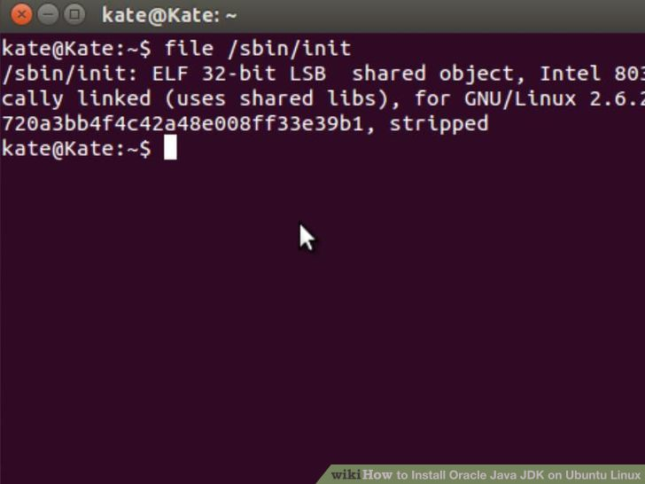](http://www.wikihow.com/Install-Oracle-Java-JDK-on-Ubuntu-Linux#/Image:Install-Oracle-Java-JDK-on-Ubuntu-Linux-Step-1.jpg)

1

**Check to see if your Ubuntu Linux operating system architecture is 32-bit or 64-bit, open up a terminal and run the following command below.**

* + **Type/Copy/Paste:** file /sbin/init
    - Note the bit version of your Ubuntu Linux operating system architecture it will display whether it is 32-bit or 64-bit.

1. [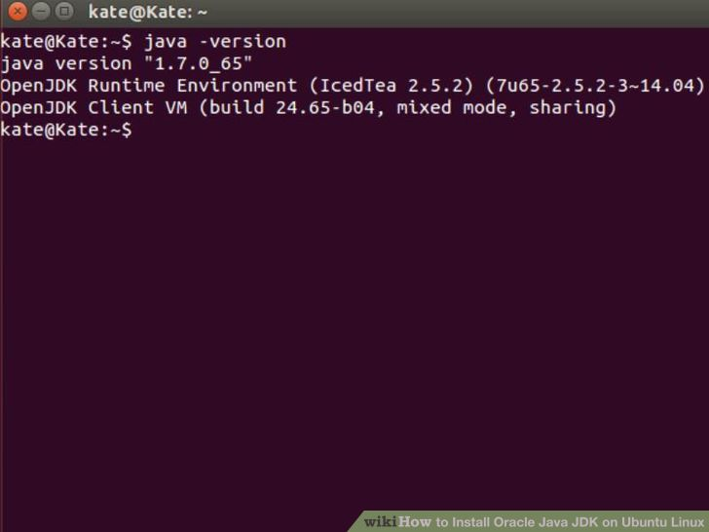](http://www.wikihow.com/Install-Oracle-Java-JDK-on-Ubuntu-Linux#/Image:Install-Oracle-Java-JDK-on-Ubuntu-Linux-Step-2.jpg)

2

**Check if you have Java installed on your system.** To do this, you will have to run the Java version command from terminal.

* + Open up a terminal and enter the following command:
    - **Type/Copy/Paste:** java -version
  + If you have OpenJDK installed on your system it may look like this:
    - java version "1.7.0_15"  
      OpenJDK Runtime Environment (IcedTea6 1.10pre) (7b15~pre1-0lucid1)  
      OpenJDK 64-Bit Server VM (build 19.0-b09, mixed mode)
  + If you have OpenJDK installed on your system, you have the wrong vendor version of Java installed for this exercise.

1. [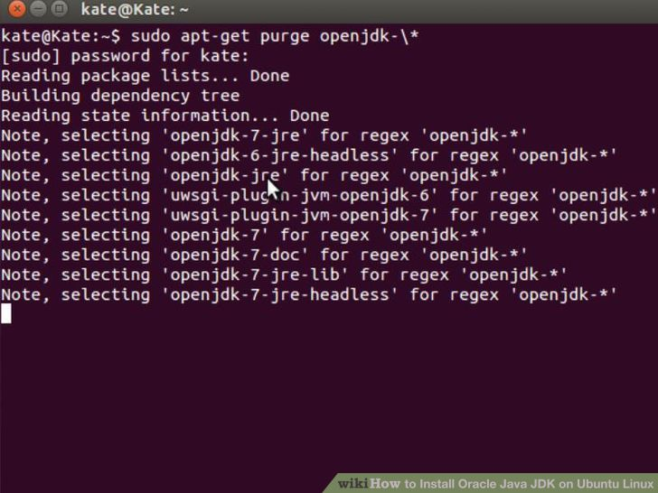](http://www.wikihow.com/Install-Oracle-Java-JDK-on-Ubuntu-Linux#/Image:Install-Oracle-Java-JDK-on-Ubuntu-Linux-Step-3.jpg)

3

**Completely remove the OpenJDK/JRE from your system and create a directory to hold your Oracle Java JDK/JRE binaries.** This will prevent system conflicts and confusion between different vendor versions of Java. For example, if you have the OpenJDK/JRE installed on your system, you can remove it by typing the following at the command line:

* + **Type/Copy/Paste:** sudo apt-get purge openjdk-\*
    - This command will completely remove OpenJDK/JRE from your system
  + **Type/Copy/Paste:** sudo mkdir -p /usr/local/java
    - This command will create a directory to hold your Oracle Java JDK and JRE binaries.

1. [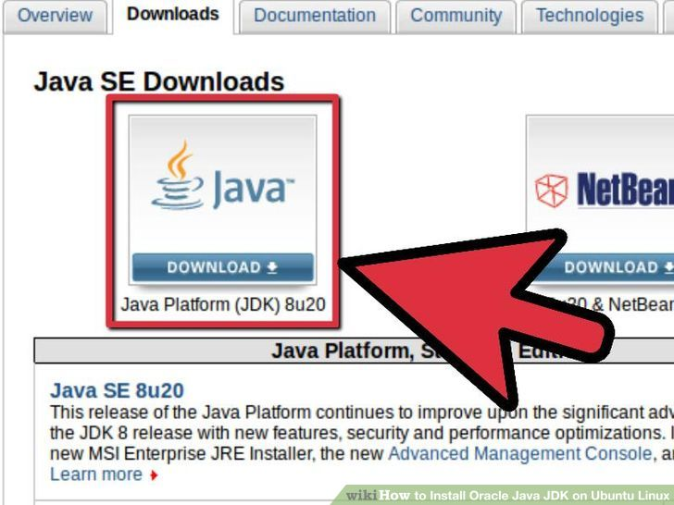](http://www.wikihow.com/Install-Oracle-Java-JDK-on-Ubuntu-Linux#/Image:Install-Oracle-Java-JDK-on-Ubuntu-Linux-Step-4.jpg)

4

**[Download the Oracle Java JDK for Linux](http://www.oracle.com/technetwork/java/javase/downloads/index.html)**. Make sure you select the **correct** compressed binaries for your system architecture 32-bit or 64-bit (which end in tar.gz).

* + For example, if you are on Ubuntu Linux 32-bit operating system download 32-bit Oracle Java binaries.
  + For example, if you are on Ubuntu Linux 64-bit operating system download 64-bit Oracle Java binaries.
  + Optional, [**Download the Oracle Java JDK Documentation**](http://www.oracle.com/technetwork/java/javase/documentation/java-se-7-doc-download-435117.html)
    - Select jdk-8u20-apidocs.zip
  + **Important Information:** 64-bit Oracle Java binaries do not work on 32-bit Ubuntu Linux operating systems, you will receive multiple system error messages, if you attempt to install 64-bit Oracle Java on 32-bit Ubuntu Linux.

1. [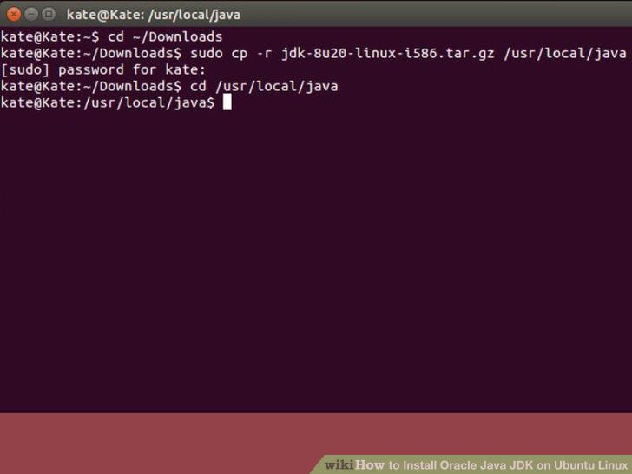](http://www.wikihow.com/Install-Oracle-Java-JDK-on-Ubuntu-Linux#/Image:Install-Oracle-Java-JDK-on-Ubuntu-Linux-Step-5.jpg)

5

**Copy the Oracle Java binaries into the /usr/local/java directory.** In most cases, the Oracle Java binaries are downloaded to: /home/**"your_user_name"**/Downloads.

* + **32-bit Oracle Java on 32-bit Ubuntu Linux installation instructions:**
    - **Type/Copy/Paste:** cd /home/**"your_user_name"**/Downloads
    - **Type/Copy/Paste:** sudo cp -r jdk-8u20-linux-i586.tar.gz /usr/local/java/
    - **Type/Copy/Paste:** cd /usr/local/java
  + **64-bit Oracle Java on 64-bit Ubuntu Linux installation instructions:**
    - **Type/Copy/Paste:** cd /home/**"your_user_name"**/Downloads
    - **Type/Copy/Paste:** sudo cp -r jdk-8u20-linux-x64.tar.gz /usr/local/java/
    - **Type/Copy/Paste:** cd /usr/local/java

1. [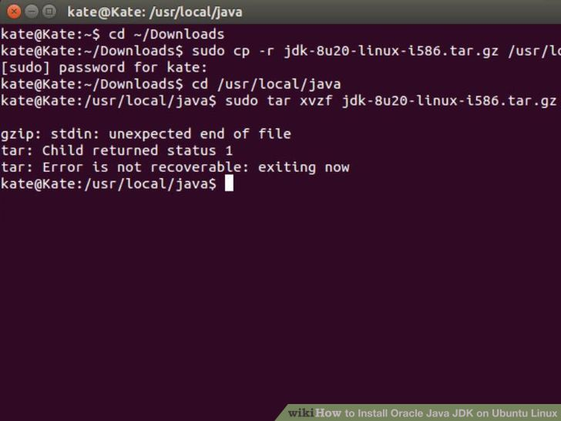](http://www.wikihow.com/Install-Oracle-Java-JDK-on-Ubuntu-Linux#/Image:Install-Oracle-Java-JDK-on-Ubuntu-Linux-Step-6.jpg)

6

**Unpack the compressed Java binaries, in the directory /usr/local/java**

* + **32-bit Oracle Java on 32-bit Ubuntu Linux installation instructions:**
    - **Type/Copy/Paste:** sudo tar xvzf jdk-8u20-linux-i586.tar.gz
  + **64-bit Oracle Java on 64-bit Ubuntu Linux installation instructions:**
    - **Type/Copy/Paste:** sudo tar xvzf jdk-8u20-linux-x64.tar.gz

1. [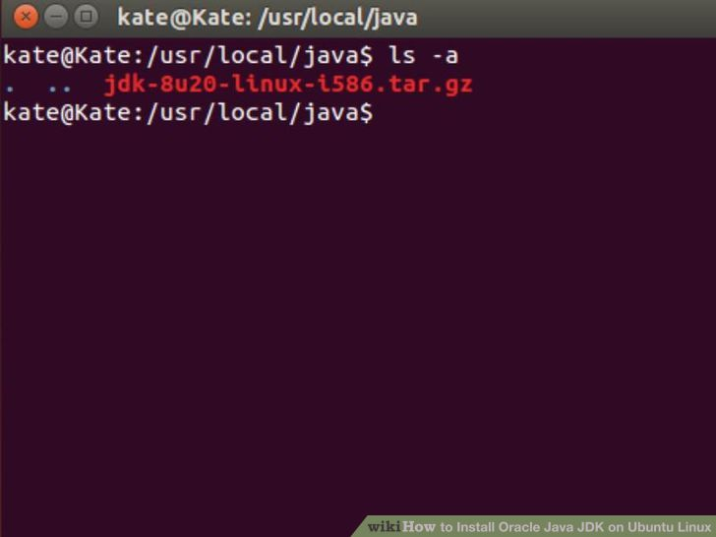](http://www.wikihow.com/Install-Oracle-Java-JDK-on-Ubuntu-Linux#/Image:Install-Oracle-Java-JDK-on-Ubuntu-Linux-Step-7.jpg)

7

**Double-check your directories.** At this point, you should have two uncompressed binary directories in /usr/local/java for the Java JDK/JRE listed as:

* + **Type/Copy/Paste:** ls -a
  + **jdk1.8.0_20**
  + **jre1.8.0_20**

1. [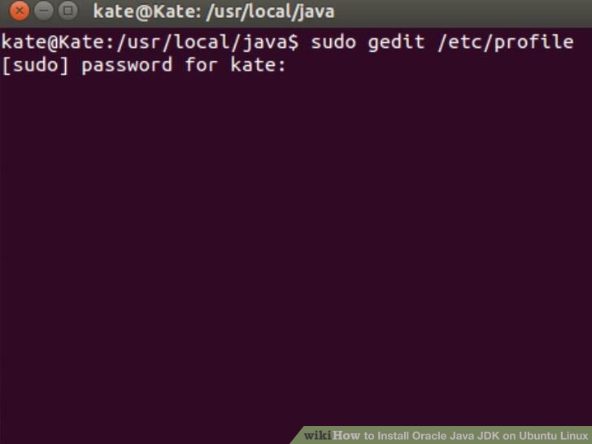](http://www.wikihow.com/Install-Oracle-Java-JDK-on-Ubuntu-Linux#/Image:Install-Oracle-Java-JDK-on-Ubuntu-Linux-Step-8.jpg)

8

**Edit the system PATH file /etc/profile and add the following system variables to your system path.** Use nano, gedit or any other text editor, as root, open up /etc/profile.

* + **Type/Copy/Paste:** sudo gedit /etc/profile
  + **or**
  + **Type/Copy/Paste:** sudo nano /etc/profile

1. [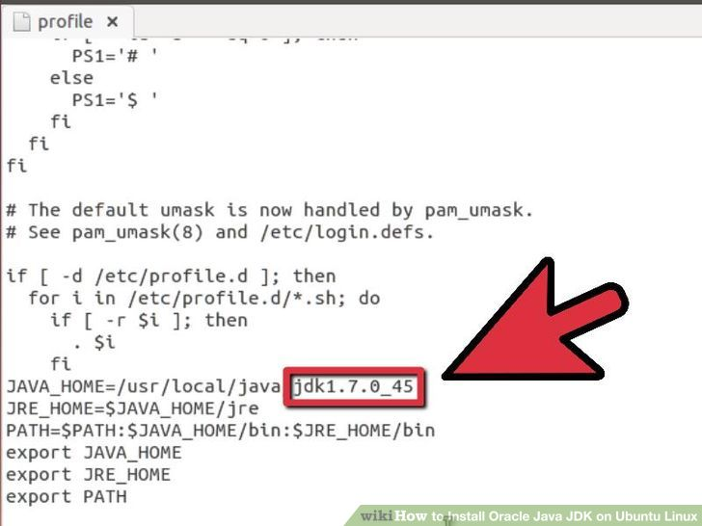](http://www.wikihow.com/Install-Oracle-Java-JDK-on-Ubuntu-Linux#/Image:Install-Oracle-Java-JDK-on-Ubuntu-Linux-Step-9.jpg)

9

**Scroll down to the end of the file using your arrow keys and add the following lines below to the end of your /etc/profile file:**

* + **Type/Copy/Paste:**  
      
    JAVA_HOME=/usr/local/java/**jdk1.8.0_20**  
    JRE_HOME=/usr/local/java/**jre1.8.0_20**  
    PATH=$PATH:$JRE_HOME/bin:$JAVA_HOME/bin  
    export JAVA_HOME  
    export JRE_HOME  
    export PATH

1. [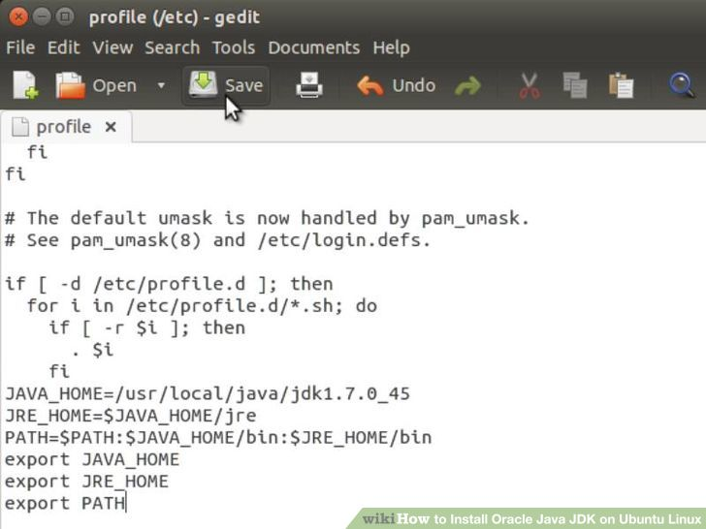](http://www.wikihow.com/Install-Oracle-Java-JDK-on-Ubuntu-Linux#/Image:Install-Oracle-Java-JDK-on-Ubuntu-Linux-Step-10.jpg)

10

**Save the /etc/profile file and exit.**

1. [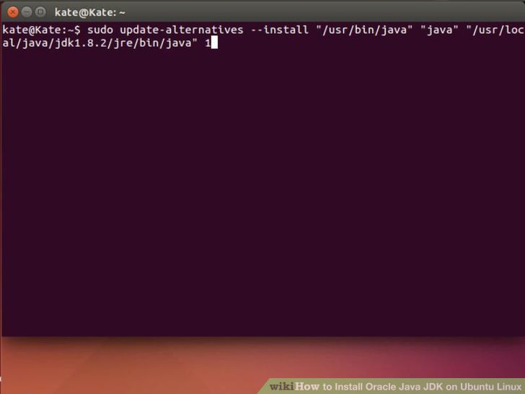](http://www.wikihow.com/Install-Oracle-Java-JDK-on-Ubuntu-Linux#/Image:Install-Oracle-Java-JDK-on-Ubuntu-Linux-Step-11.jpg)

11

**Inform your Ubuntu Linux system where your Oracle Java JDK/JRE is located.** This will tell the system that the new Oracle Java version is available for use.

* + **Type/Copy/Paste:** sudo update-alternatives --install "/usr/bin/java" "java" "/usr/local/java/jdk1.8.0_20/bin/java" 1
    - this command notifies the system that Oracle Java JRE is available for use
  + **Type/Copy/Paste:** sudo update-alternatives --install "/usr/bin/javac" "javac" "/usr/local/java/jdk1.8.0_20/bin/javac" 1
    - this command notifies the system that Oracle Java JDK is available for use
  + **Type/Copy/Paste:** sudo update-alternatives --install "/usr/bin/javaws" "javaws" "/usr/local/java/jdk1.8.0_20/bin/javaws" 1
    - this command notifies the system that Oracle Java Web start is available for use

1. [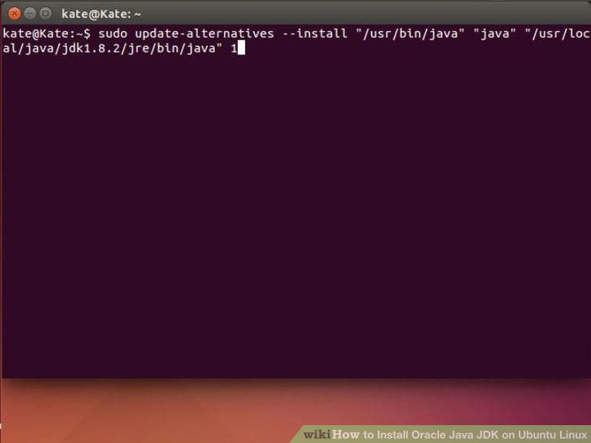](http://www.wikihow.com/Install-Oracle-Java-JDK-on-Ubuntu-Linux#/Image:Install-Oracle-Java-JDK-on-Ubuntu-Linux-Step-12.jpg)

12

**Inform your Ubuntu Linux system that Oracle Java JDK/JRE must be the default Java.**

* + **Type/Copy/Paste:** sudo update-alternatives --set java /usr/local/java/jdk1.8.0_20/bin/java
    - this command will set the java runtime environment for the system
  + **Type/Copy/Paste:** sudo update-alternatives --set javac /usr/local/java/jdk1.8.0_20/bin/javac
    - this command will set the javac compiler for the system
  + **Type/Copy/Paste:** sudo update-alternatives --set javaws /usr/local/java/jdk1.8.0_20/bin/javaws
    - this command will set Java Web start for the system

1. [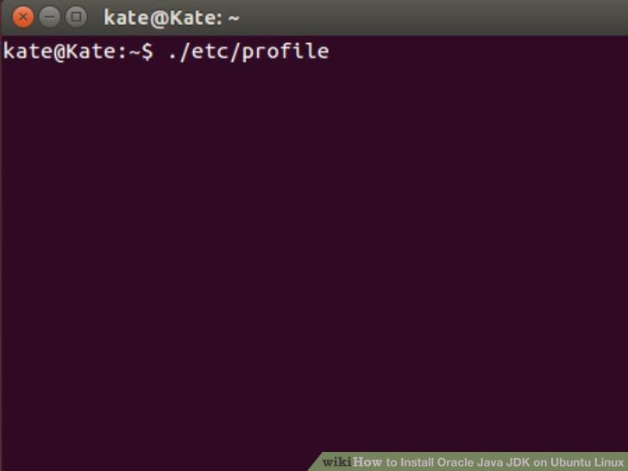](http://www.wikihow.com/Install-Oracle-Java-JDK-on-Ubuntu-Linux#/Image:Install-Oracle-Java-JDK-on-Ubuntu-Linux-Step-13.jpg)

13

**Reload your system wide PATH /etc/profile by typing the following command:**

* + **Type/Copy/Paste:** source /etc/profile
  + Note your system-wide PATH /etc/profile file will reload after reboot of your Ubuntu Linux system

1. [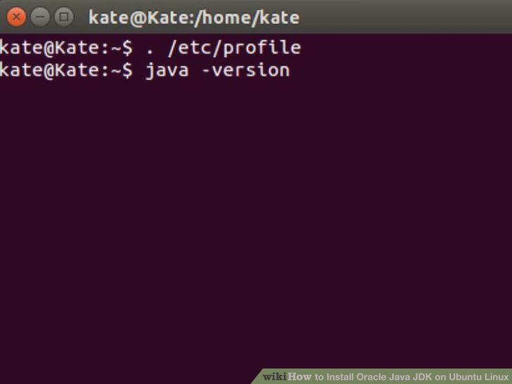](http://www.wikihow.com/Install-Oracle-Java-JDK-on-Ubuntu-Linux#/Image:Install-Oracle-Java-JDK-on-Ubuntu-Linux-Step-14.jpg)

14

**Test to see if Oracle Java was installed correctly on your system.** Run the following commands and note the version of Java:

1. [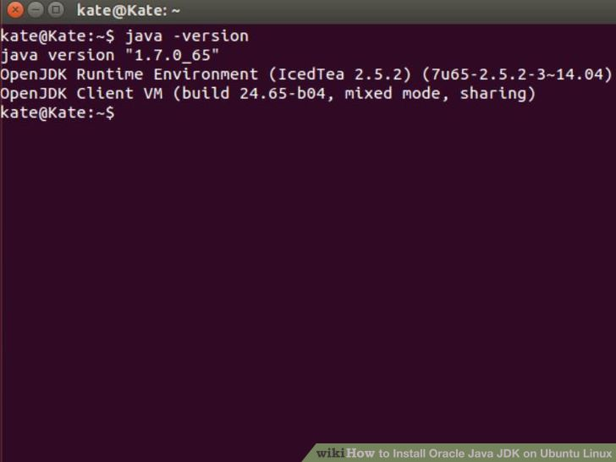](http://www.wikihow.com/Install-Oracle-Java-JDK-on-Ubuntu-Linux#/Image:Install-Oracle-Java-JDK-on-Ubuntu-Linux-Step-15.jpg)

15

**A successful installation of 32-bit Oracle Java will display:**

* + **Type/Copy/Paste:** java -version
    - This command displays the version of java running on your system
  + You should receive a message which displays:
    - java version "1.8.0_20"  
      Java(TM) SE Runtime Environment (build 1.8.0_20-b26)  
      **Java HotSpot(TM) Server VM (build 25.20-b23, mixed mode)**
  + **Type/Copy/Paste:** javac -version
    - This command lets you know that you are now able to compile Java programs from the terminal.
  + You should receive a message which displays:
    - javac 1.8.0_20

1. [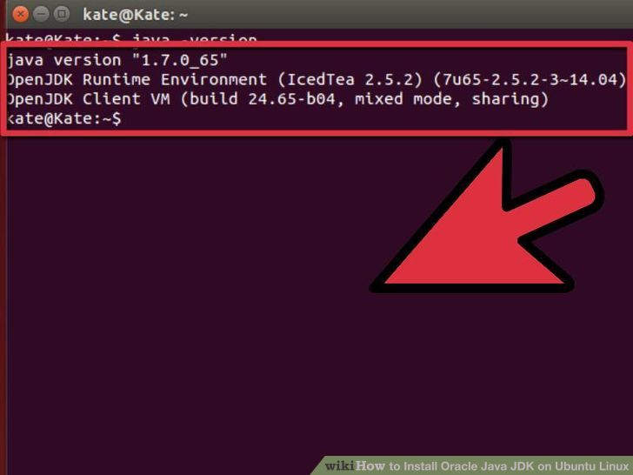](http://www.wikihow.com/Install-Oracle-Java-JDK-on-Ubuntu-Linux#/Image:Install-Oracle-Java-JDK-on-Ubuntu-Linux-Step-16.jpg)

16

**A successful installation of Oracle Java 64-bit will display:**

* + **Type/Copy/Paste:** java -version
    - This command displays the version of java running on your system
  + You should receive a message which displays:
    - java version "1.8.0_20"  
      Java(TM) SE Runtime Environment (build 1.8.0_20-b26)  
      **Java HotSpot(TM) Server VM (build 25.20-b23, mixed mode)**
  + **Type/Copy/Paste:** javac -version
    - This command lets you know that you are now able to compile Java programs from the terminal.
  + You should receive a message which displays:
    - javac 1.8.0_20

1. [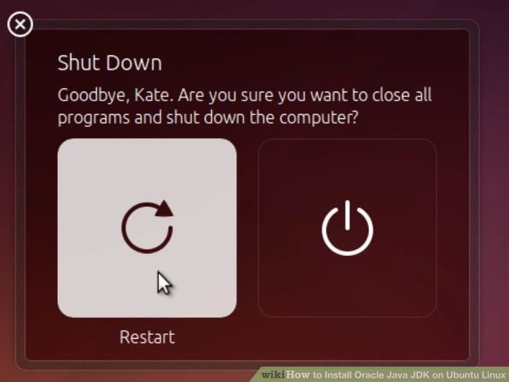](http://www.wikihow.com/Install-Oracle-Java-JDK-on-Ubuntu-Linux#/Image:Install-Oracle-Java-JDK-on-Ubuntu-Linux-Step-17.jpg)

17

**Congratulations, you just installed Oracle Java on your Linux system.** Now reboot your Ubuntu Linux system. Afterwards, your system will be fully configured for running and developing Java programs. Later on you may want to try compiling and running your own Java programs by following this article [How to Create your First Java Program on Ubuntu Linux](http://www.wikihow.com/Create-Your-First-Java-Program-on-Ubuntu-Linux)